Energy Audit Report
Energy Audit Voucher Scheme
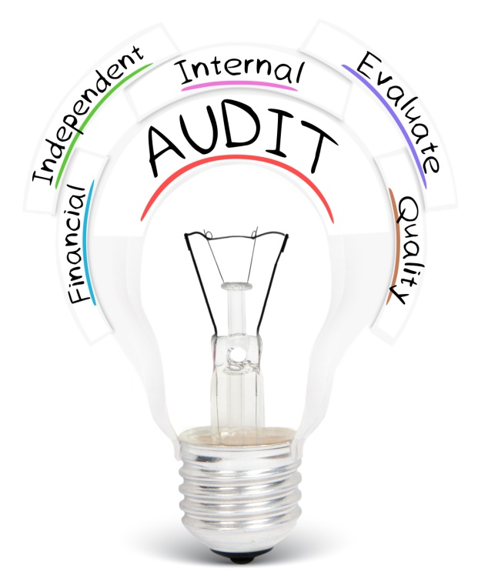

For office use only

Reference Number:

Date Received by ME:

Name of Beneficiary:

Name of Energy Auditor:

Complete Energy Audit Report:
Approved by E&WA (Full Name):

Approved by E&WA (Signature):

Date Approved by E&WA:

- Details of the undertaking being audited
  - Company Name
(the details in this section should be identical to those specified in the Energy Voucher issued by Malta Enterprise)

  - Company Number / ID or other reference

  - VAT Number

  - Registered Address

  - Address of Beneficiary where audit is being undertaken

  - General E-mail Address

  - Contact Details

    - Contact Person

    - Designation

    - E-mail Address

    - Telephone/Mobile Number

- Details of the Energy Auditor
  - Full Name

  - Qualifications of Energy Auditor

  - E-mail Address

  - Telephone Number

- Background information on the organisation
  - General information on the organisation

  - NACE Code

  - Number of staff headcount

    - Number of Annual Work Units (AWU)

    - Full-timers

    - Part-timers

  - Total area of premises m²

  - Total annual business hours hrs

- Main Energy Consuming/Generating Equipment
4.1 Lighting
Incandescent Watts

Energy Savings Watts⁶

LEDs Watts⁶

Others Watts6

Please Specify - Watts6

4.2 Air conditioning
Used for: Cooling Heating Both
Total heated cooling area: m²
Reversible Split Unit (Btu) or (kW) or (HP)
Year of installation
Please provide details above if there are more units installed

Centralised Air Condition
Qty Size (Btu)
Size (kW) Size (HP)
Year of Installation
Please provide details above if there are more units installed

Other Size (kW) Units
Year of Installation

4.3 Refrigeration
Display cabinet
Btu Watts
Please provide details above if there are more units installed

Upright freezer
Btu Watts
Please provide details above if there are more units installed

Chest Freezer
Btu Watts
Please provide details above if there are more units installed

Cold Room
Btu Watts
Please provide details above if there are more units installed

Others (Please specify)
Btu Watts
Please provide details above if there are more units installed

4.4 Water Heating
Electric Heater
Watts
Please provide details above if there are more units installed

Boiler
Watts
Please provide details above if there are more units installed

Other Energy Intensive Equipment (Please provide details)

4.5 Installed RES
Photovoltaics
kWp
Solar Water Heater
Vacuum Tube
Flat Plate
Collector Area m²
Other (Please Specify)

- Energy Consumption
5.1 Annual Electricity Consumption kWh
5.2 Annual Fuel Consumption per fuel type litres of
5.3 Annual Gas Consumption
kg or litres – bulk
or

number of 12kg cylinders
or
number of 15kg cylinders
or
number of 25kg cylinders
5.4 Annual Water Consumption
m³
5.5 Annual average Hot Water Demand
m³
5.6 Key Energy Performance Indicators (based on previous year)

5.7 Comparison of Energy Performance Indicators for the last 3 years

- Energy Audit Analysis
  - Description of Energy Audit (Define scope and boundaries of audit, audited objectives and timeframes

The Energy Audit is to include:

- High level review of consumption
- Comparison with available benchmarks to identify high energy consumption or inefficiencies
- Identification of energy savings through behavioural changes
- Identification of low cost and easily quantifiable energy improvements
- Identification of more capital intensive improvement opportunities
- Indicative or typical savings in kWh
- Ranking of opportunities for improving energy performance
- Required investment and pay back periods for the identified energy savings opportunities.

- Other
  - Identify that part of the report and/or data that the undertaking considers commercially sensitive.

- Signatures
8.1 This Report has been duly filled in and confirmed correct by the Energy Auditor:

Name of Energy Auditor (full name):

Name of Undertaking being represented

by the Energy Auditor (if applicable):

Signature of Energy Auditor:

Date:
Click here to enter a date.

8.2 On behalf of the undertaking whose facility have been covered by this audit I hereby confirm that the Energy Auditor has adequately explained the details of the Energy Audit Analysis in this report, particularly any energy efficiency issues and measures that may be adopted by the Beneficiary in order to enhance energy efficiency.

Name and Surname of signatory

authorised to represent the Beneficiary
(CAPITAL LETTERS):

Position in Establishment:

Signature:

Date:
Click here to enter a date.

Identification Number in case of Self-employed, Partnership Number in case of a Partnership or Cooperative Number in the case of a Cooperative
Please provide a qualitative overview.
NACE is the industry standard classification system used in the European Union.
The headcount corresponds to the number of AWU, i.e. the number of persons who worked fulltime within the undertaking in question or on its behalf during the entire reference year under consideration. The work of persons who have not worked the full year, the work of those who have worked part-time, regardless of the duration, and the work of seasonal workers are counted as fraction of AWU. The staff consists of: - Employees - Persons working for the undertaking being subordinated to it and deemed to be employees under national law - Owner-managers - Partners engaging in a regular activity in the undertaking and benefitting from financial advantages from the undertaking. Apprentices or students engaged in vocational training with an apprenticeship or vocational training contract are not included as staff. The duration of maternity and paternity leave is not counted.
This item refers to the total number of business hours in a typical year based on an ‘open business’ work schedule.
Please specify total wattage.
Type of equipment with a brief note on function, size in watts, year of installation, If necessary insert additional documentation.
Please provide type of technology and size.
Insert fuel type.
Please include the indicator together with a short description of how this indicator is calculated in a separate document.
Please provide a qualitative overview.
Please provide a qualitative overview.

